CERTIFICATE OF ATTENDANCE

This is to certify that

Dr. Lorem Ipsum
Experienced researcher from

the company Lorem, Paris, France

performed her secondment to
the University of Novi Sad (UNS), Serbia
in the period: 00/00/2020 ÷ 00/00/2020

in the framework of the H2020 project MSCA RISE,
“Innovative bio-inspired sensors and microfluidic devices for saliva-based theranostics of oral and systemic diseases” – SALSETH, no. 872370

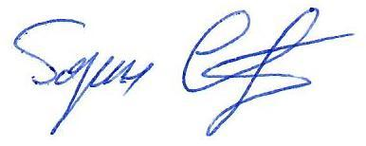

______________________________
Prof. Dr Goran Stojanović
SALSETH project coordinator and UNS Team leader

